**Teachers Feedback Analysis 2023-24**

Faculty plays an important role in establishing the importance of an educational institution in the society. Feedback was collected from faculty members to provide them the necessary facilities for the effective delivery of the curriculum and quality enhancement. Detailed analysis is given as under:

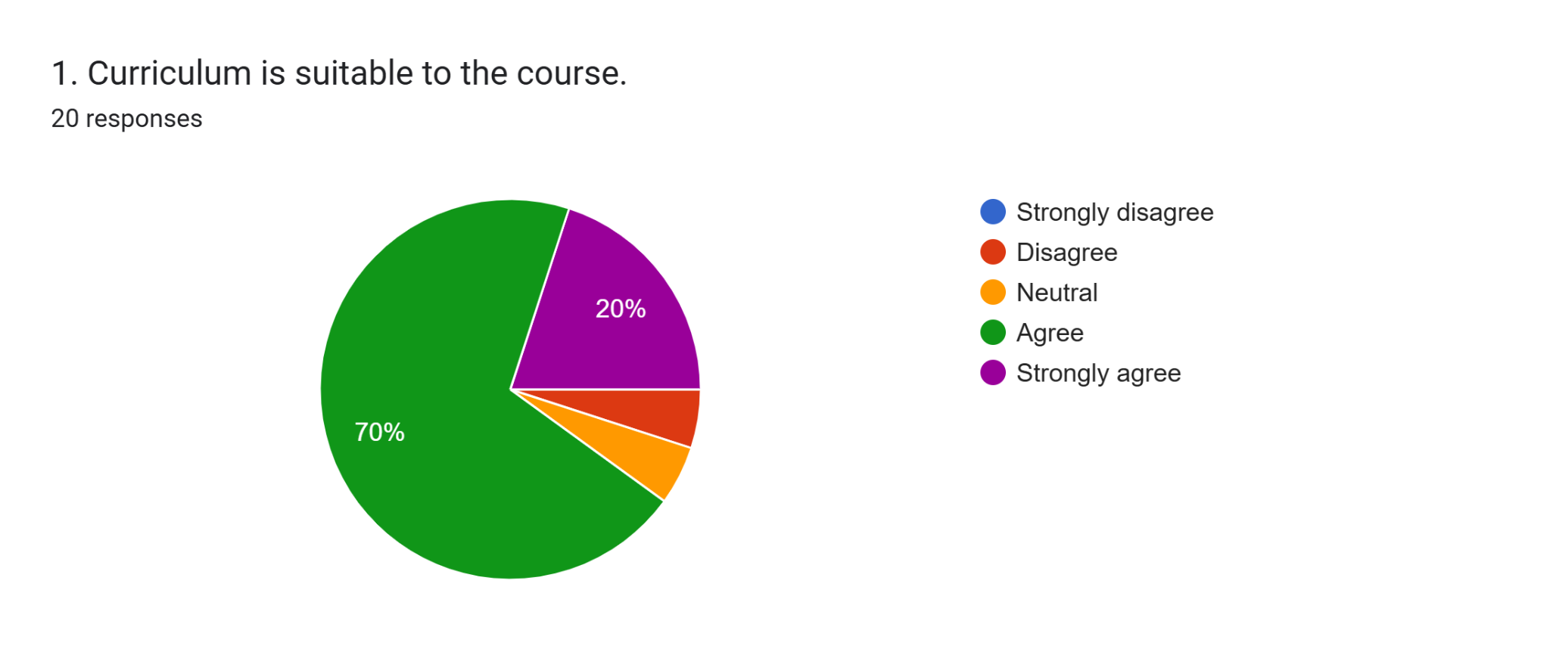

90% teachers agree that the Curriculum is suitable to the course

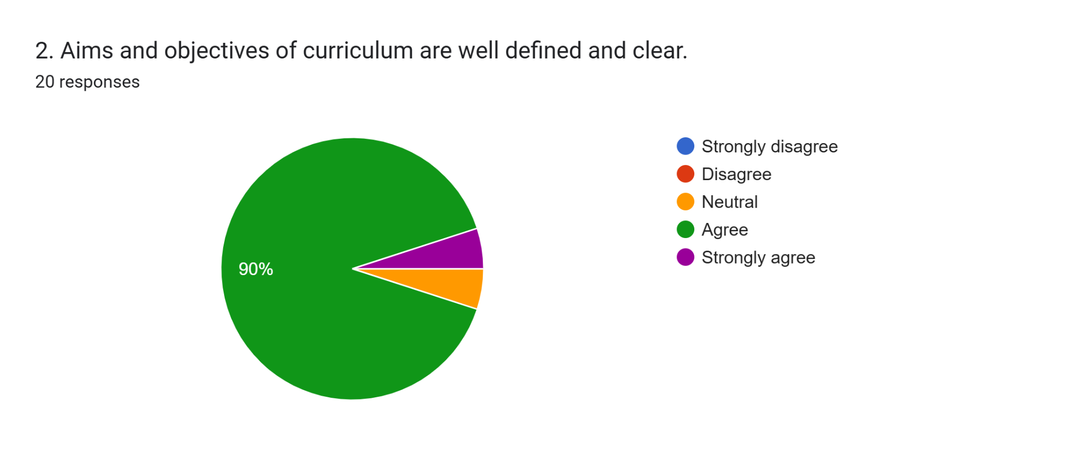

95 percent teachers agree that aims and objectives of curriculum are well defined

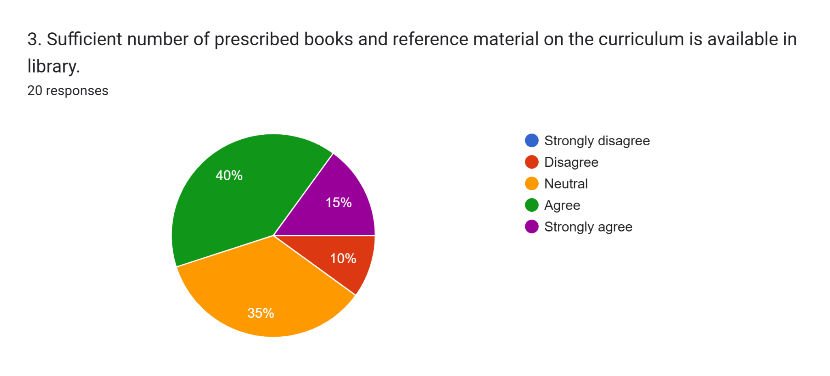

55% teachers agree that sufficient number of prescribed books and reference material on the curriculum is available in library while 35% are neutral.

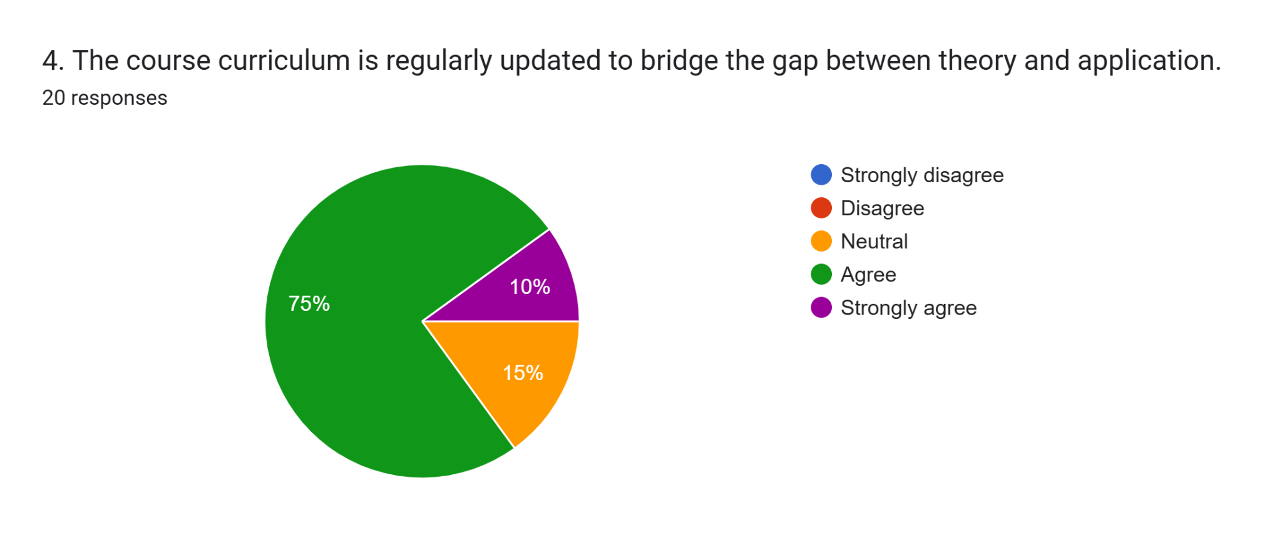

85 percent teachers agree that he course curriculum is regularly updated to bridge the gap between theory and application, 15 percent are neutral.

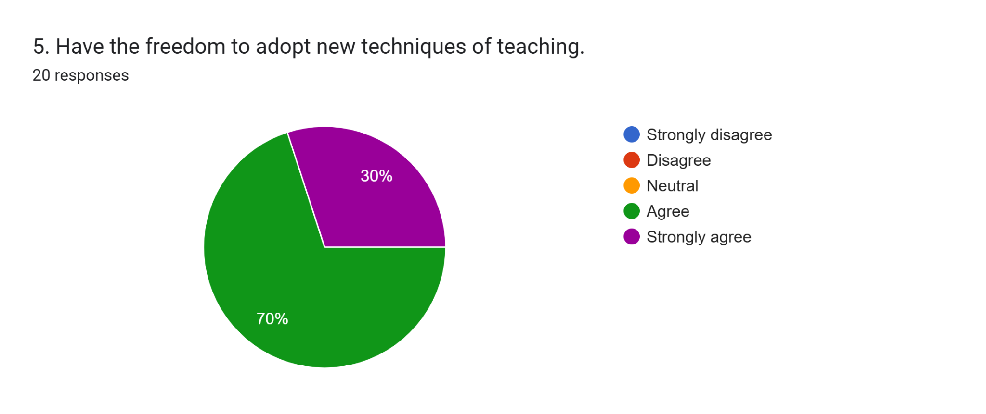

All teachers agree that they have freedom to adopt new teaching techniques

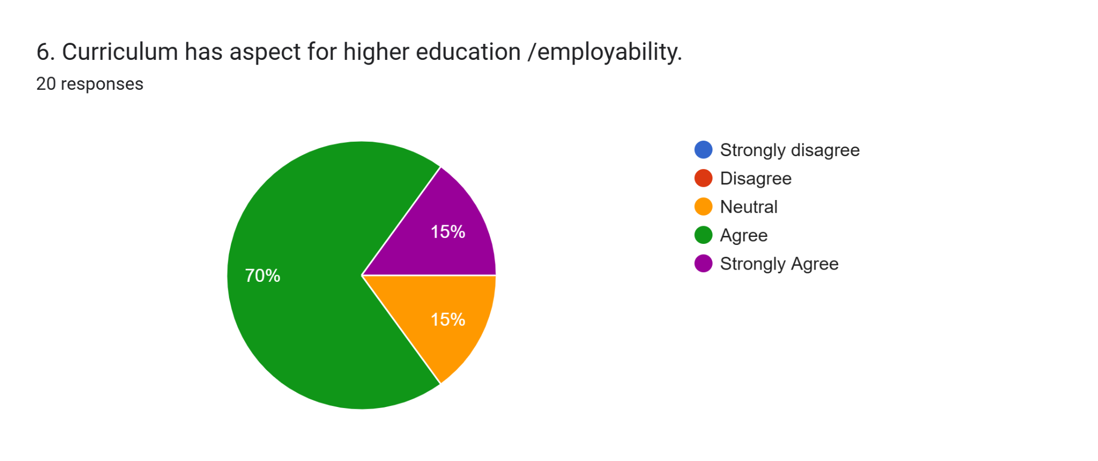

85 percent teachers agree that curriculum has aspect for higher education /employability. 15% are neutral

.

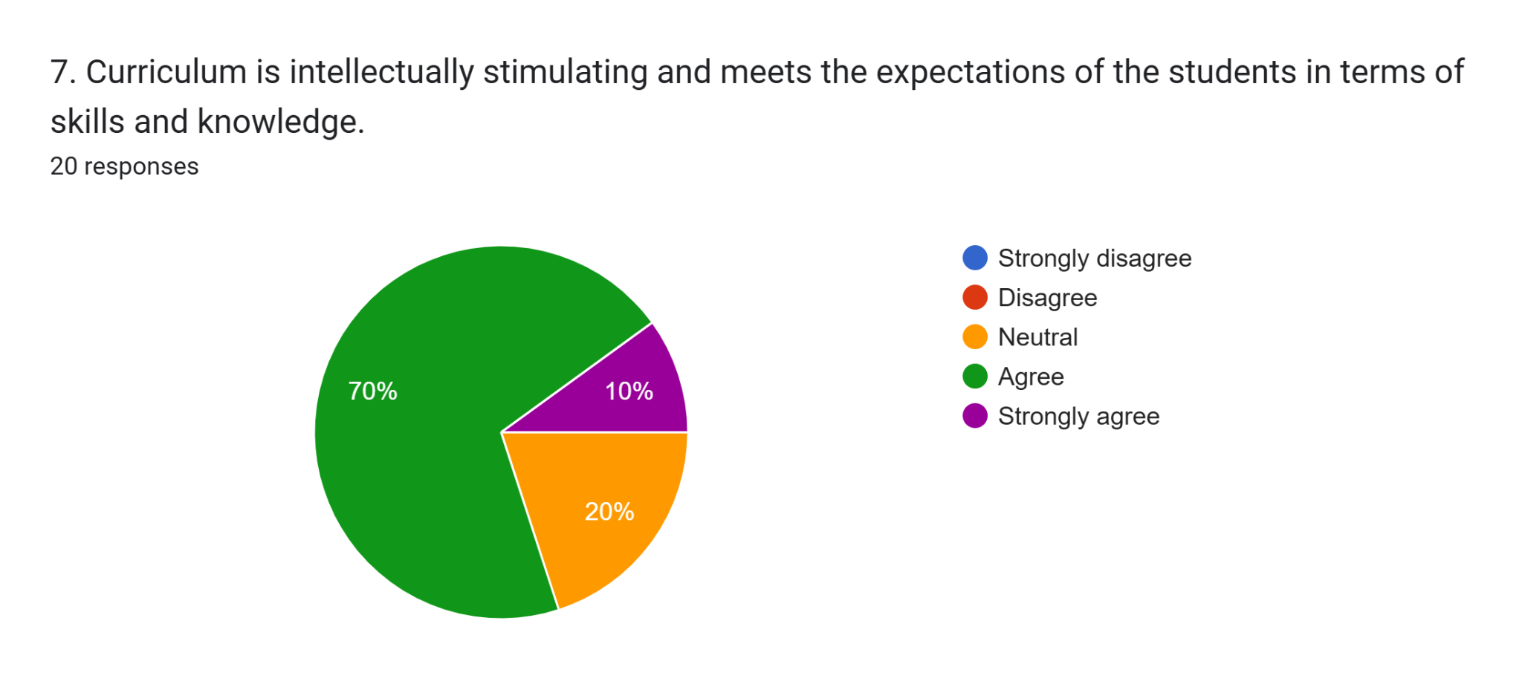

80 percent teachers agree that curriculum is intellectually stimulating and meets the expectations of the students in terms of skills and knowledge while 20 percent are neutral.

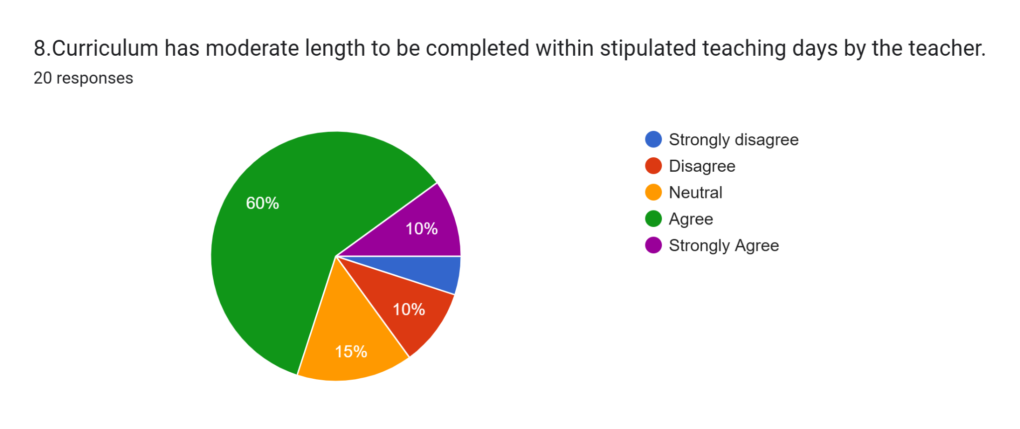

70% percent teachers agree that curriculum has moderate length to be completed within stipulated teaching days by the teacher while 15 percent are neutral.

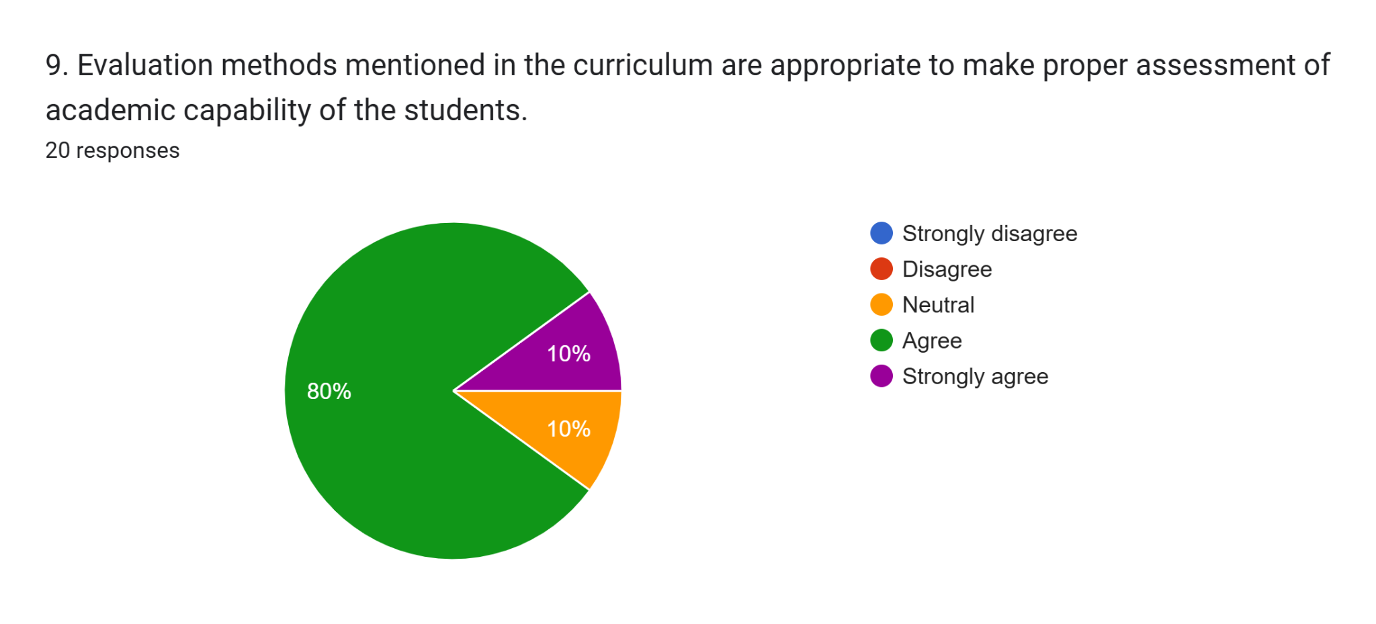

90% teachers agree that evaluation methods mentioned in the curriculum are appropriate to make proper assessment of academic capability of the students.

.

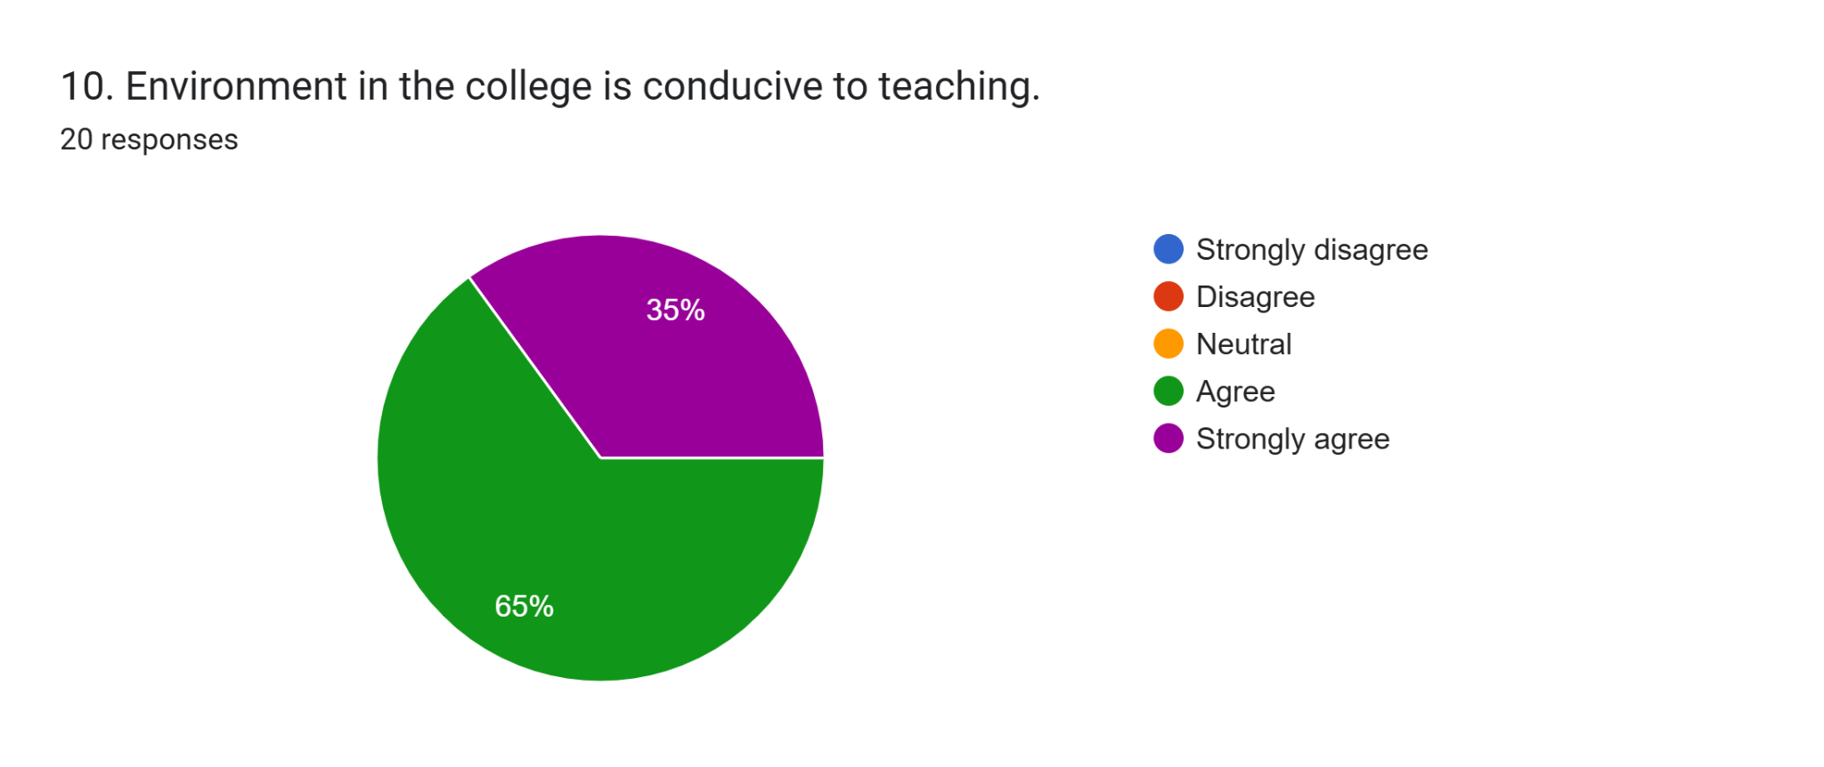

All teachers agree that environment in the college is conducive to teaching

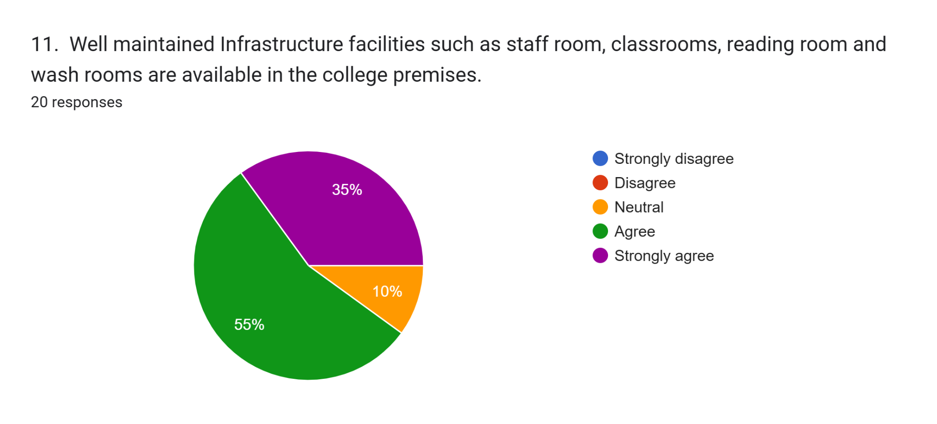

90 percent teachers agree that well maintained Infrastructure facilities such as staff room, classrooms, reading room and wash rooms are available in the college premises, 10 percent are neutral.

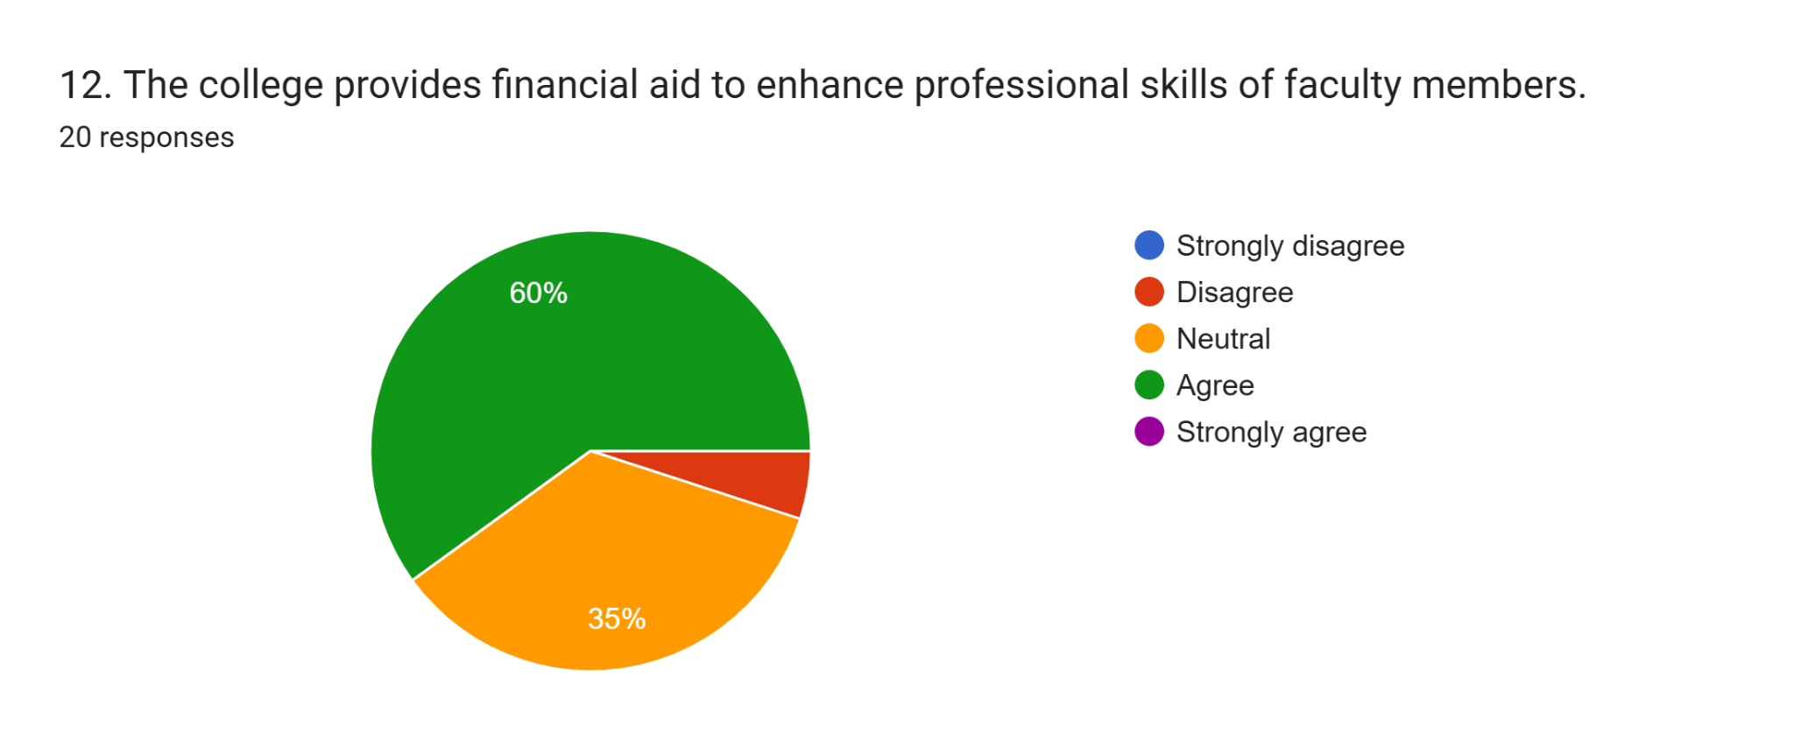60 percent teachers agree that college provides financial aid to enhance professional skills of faculty members, 35 percent are neutral.

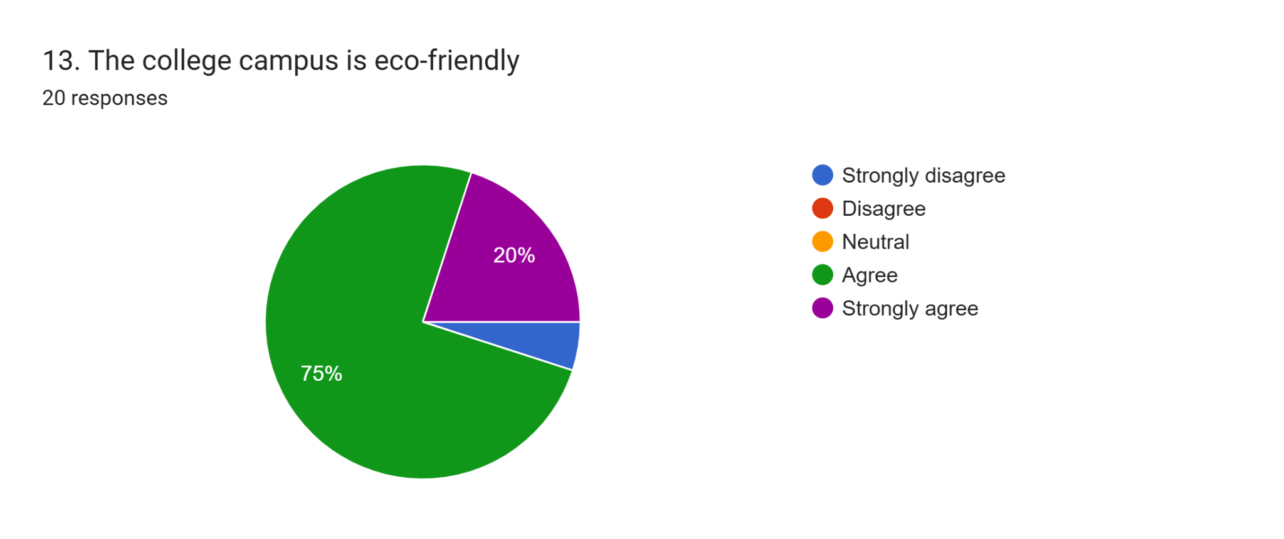 95%teachers agree that the college campus is eco-friendly